Please create a Python program that expects a kilogram input value and converts that value to grams, pounds, and ounces when the user pushes the convert button.

The program would look similar to the one in the following picture:

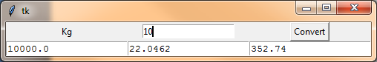

**Tip:**

1 kg = 1000 grams

1 kg = 2.20462 pounds

1 kg = 35.274 ounces